**ASSIGNMENT 5.5**

**PROBLEM STATEMENT :**

Write a map only job for the word count program and set the output format as sequence file output format.

**STEP 1:**

The mapreduce program for the given problem statement is written in the java environment.

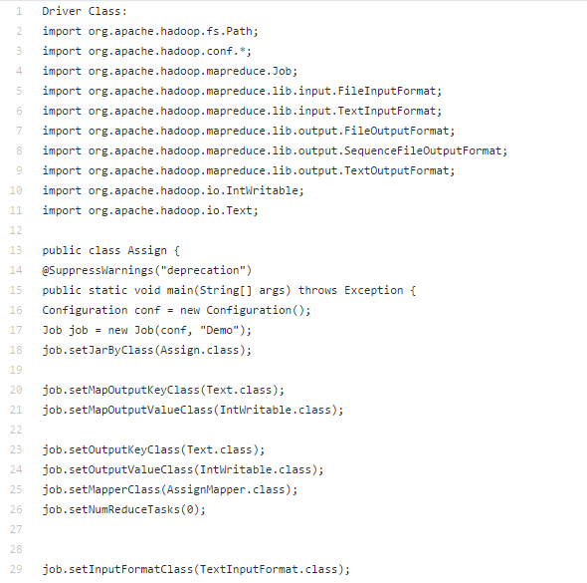

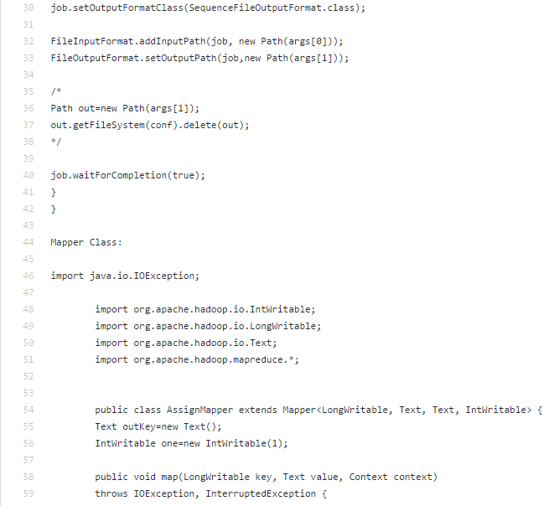

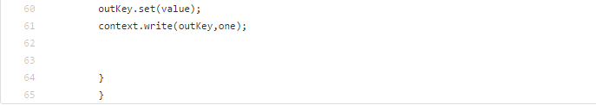

**OUTPUT :**

The output for the required program is represented below:

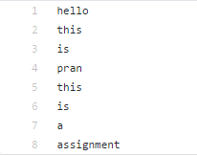

**EXECUTION PROCESS :**

The execution process for the required program in the hadoop environment is shown below.

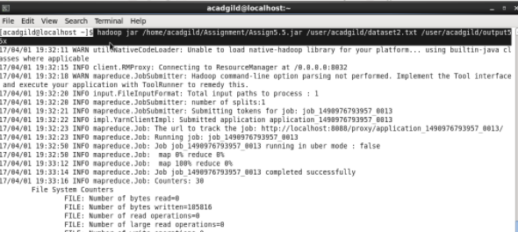

**OUTPUT :**

